**Question1:Copy the whole question to ChatGPT**

Answer:(1)

+-----------------------+

|Order Processing|

| System |

+-----------------------+

/\

/ \

/ \

/ \

/ \

/ \

+-----------------+ +--------------------+

| Customer| | Customer |

| | | Representative |

+-----------------+ +--------------------+

- Place Order - Place Order

- Check Order Status - Check Order Status

- Cancel Order - Cancel Order

- Request Catalog - Request Catalog

- Return Product - Return Product (Phone only)

(2)

+-----------------+

| Customer |

+-----------------+

| - customerID |

| - name |

| - address |

| - isGold |

| - bonusPoints |

+-----------------+

| +--------------------+

|1 | Order |

| +--------------------+

| - orderID |

| - customer |

| - products |

| - shippingAddress |

| - billingAddress |

| - creditCardNumber |

| - totalCost |

| +--------------------+

|1 |

| | *

| |

| |

| |

+--------------------+ |

| Product | |

+--------------------+ |

| - productID | |

| - name | |

| - price | |

| - description | |

| - picture | |

| - availability | |

+--------------------+ |

|

|

+-------------+

| Catalog |

+-------------+

| - products|

+-------------+

(3) +-----------------------+

| Order Processing |

| System |

+-----------------------+

/\

/ \

/ \

/ \

/ \

/ \

+-----------------+ +--------------------+

| Customer | | Catalog |

+-----------------+ +--------------------+

| - customerID | | - products |

| - name | +--------------------+

| - address |

| - isGold |

| - bonusPoints |

+-----------------+

|

|1

| GetProductAvailability(productID)

|

|

| +-----------------+

| | Product |

| +-----------------+

| | - productID |

| | - name |

| | - price |

| | - description |

| | - picture |

| | - availability |

| +-----------------+

|

|2

| AddProductToBasket(product, quantity)

|

|

|3

| ConfirmOrder()

|

|

| +--------------------+

| | Order |

| +--------------------+

| | - orderID |

| | - customer |

| | - products |

| | - shippingAddress |

| | - billingAddress |

| | - creditCardNumber |

| | - totalCost |

| +--------------------+

|

|4

| CompleteOrder()

|

|

| +--------------------+

| | AccountingSystem |

| +--------------------+

| | - invoice |

| | - cost |

| +--------------------+

|

|5

| ForwardToShippingCompany(order)

|

|

| +-----------------+

| | ShippingCompany |

| +-----------------+

| | - orders |

| +-----------------+

|

|6

| FillAndShipOrder(order)

|

**Question2: For above diagram write me a PLANTUML CODE**

Answer：Certainly! Here's the PlantUML code for the UML Use Case Diagram, UML Class Diagram, and UML Sequence Diagram:

UML Use Case Diagram:

plantumlCopy code

@startuml

left to right direction

actor "Customer" as customer

actor "Customer\nRepresentative" as representative

rectangle "Order Processing System" {

customer -- (Place Order)

customer -- (Check Order Status)

customer -- (Cancel Order)

customer -- (Request Catalog)

customer -- (Return Product)

representative -- (Place Order)

representative -- (Check Order Status)

representative -- (Cancel Order)

}

@enduml

UML Class Diagram:

plantumlCopy code

@startuml

class Customer {

- customerID

- name

- address

- isGold

- bonusPoints

}

class Order {

- orderID

- customer

- products

- shippingAddress

- billingAddress

- creditCardNumber

- totalCost

}

class Product {

- productID

- name

- price

- description

- picture

- availability

}

class Catalog {

- products

}

Customer -- Order

Order "1" -- "*" Product

Catalog -- Product

@enduml

UML Sequence Diagram:

plantumlCopy code

@startuml

actor Customer

participant Catalog

participant Product

participant Order

participant AccountingSystem

participant ShippingCompany

Customer -> Catalog: GetProductAvailability(productID)

Customer -> Product: AddProductToBasket(product, quantity)

Customer -> Order: ConfirmOrder()

Customer -> Order: CompleteOrder()

Customer -> AccountingSystem: ForwardToShippingCompany(order)

Customer -> ShippingCompany: FillAndShipOrder(order)

@enduml

**Question3:I use PLANTUML to construct UML by using the code above.**

Answer:(1)

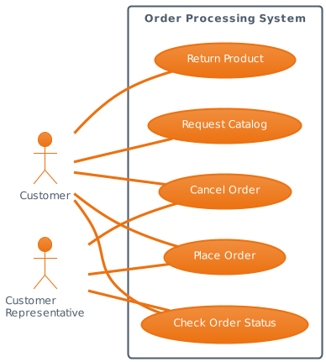

(2)

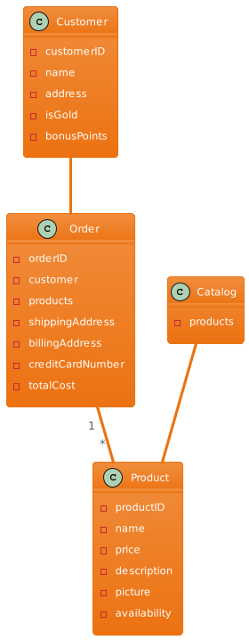

(3)

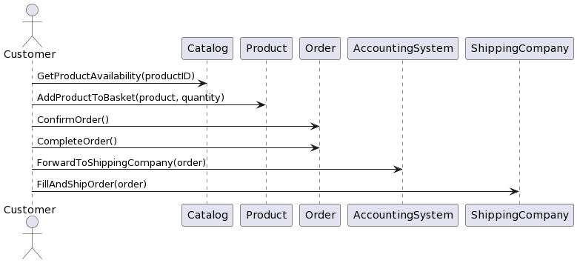

Conclusion:I have used ChatGPT to generate UML diagrams directly and also to generate PlantUML code through chat interactions. It is evident that in the first case, the overall framework of the generated UML is problematic and cannot be used. This aligns with the issues I have faced when using ChatGPT to generate UML diagrams in my regular practice. Apart from the content itself, the overall design framework is inadequate. However, when I ask ChatGPT to generate PlantUML code, the resulting code significantly improves the overall framework. After using the code with PlantText, a UML visualization tool, it becomes clear that ChatGPT excels in identifying keywords, defining variables, and structuring method bodies. It effectively captures the essence and generates UML with minimal redundancy. However, there are still significant issues with directly rendering the UML diagrams, making them unsuitable for immediate use. It would be more suitable to leverage ChatGPT's strengths and compensate for its weaknesses by using other AI models or plugins.